A
S
A
S

B
B

(b)
(a)

S
B
S

A
A
B

(d)
(c)

S
A
S
A₅
A₃
A₁
B
B
A₇
A₄
A₂
C

(f)
(e)

communication
channel
{B_{j}}
{A_{i}}
i=1,2
j=1,2

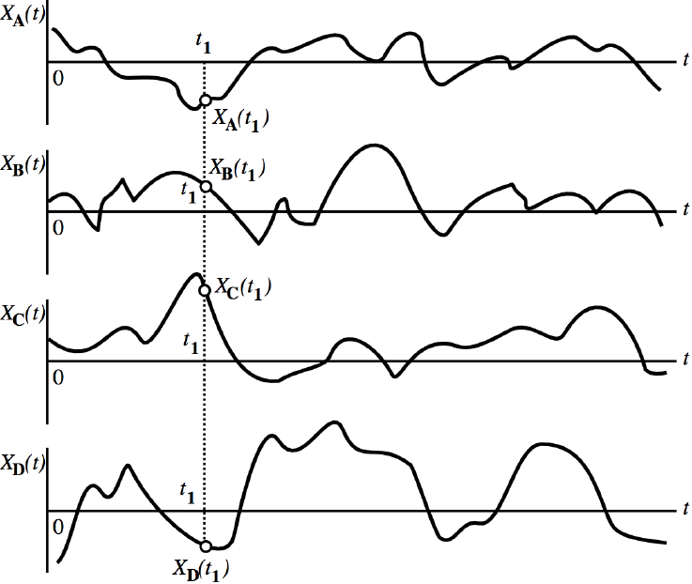

$$x_{3}(t_{1})=X(t_{1},A_{3})$$
$$x_{4}(t_{1})=X(t_{1},A_{4})$$
$$x_{1}(t_{1})=X(t_{1},A_{1})$$

$$x_{4}(t)=X(t,A_{4})$$
$$x_{3}(t)=X(t,A_{3})$$
$$x_{2}(t)=X(t,A_{2})$$
$$x_{1}(t)=X(t,A_{1})$$
$$X\left(t_{1}\right)=X(t_{1},A_{i})$$

$$x_{1}(t)=X(t,A_{1})$$

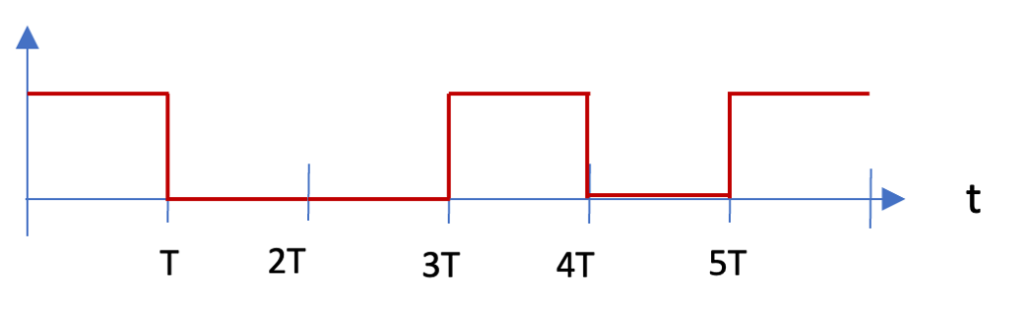
1/2
1/4
-T
T
$$τ$$
$$=πr^{2}$$
t₁
t₂


t
t
-1
1
-1
1
t₂
t₁
A
B
S
5T
4T
3T
2T
T
5T
3T
4T
2T
T
x₂ (t)
x₁ (t)
A
S
A∩B
B
A
S
(a)
(b)
(c)

